# A Tool for Developing Airport Terminal Incident Response Plans: User’s Guide

ACRP Project 04-15

IEM Inc.

In cooperation with

QuinnWilliams, LLC

Smith-Woolwine Associates, Inc.

TransSolutions, LLC

Contents

**Quick Start Tips for Tool Use** 1

Introduction 4

Purpose of the TIRP Tool 4

Purpose of This User Guide 4

Minimum System Requirement 4

What the TIRP Tool Can Do 4

Inputs 5

Processing Within the Tool 5

Outputs 5

What the TIRP Tool Cannot Do 5

**Directions for Using the Tool** 6

Frequently Asked Questions 16

Lessons Learned 20

User’s Guide Bibliography 21

**Quick Start Tips for Tool Use**

* **Insert the CD-ROM into your computer and save the tool and user guide to your desktop.**
* **It is highly recommended that you save each version of the tool with a unique name for version control!**
* **Enable content/macros – The tool cannot function without it!**



In order to operate this tool, all macros and content from Microsoft Excel **must** be enabled. On the initial opening of the tool, you should be prompted to “Enable Content” or ‘Enable Macros,” depending on your version of Excel. You can also manually enable macros by performing the following steps.

**Enable Macro Setting:**

1. In Excel go to “File,” then “Options.”
2. Click “Trust Center” on the left-hand side.
3. Click “Trust Center Settings” on the right-hand side.
4. Click “Macro Settings” on the left-hand side.
5. Select the “Enable All Macros” choice, then select “OK.”

If you do not enable macros, the tool will not remember data entered in previous pages and will not create a plan after you have entered all data.

* **Use the “Help” button when you have a question!**



**Help Button**

* **Use the Tool Tips by placing your cursor over the small red triangle symbol!**



**Tool Tips**

* **Users can add/delete the gray-and-white shaded data-entry rows (lines) in the tables as necessary—but be sure to stay within the boundaries of the table when doing so!**
* **Ensure that you close any open programs for best performance of the tool.**
* **Clipboard errors (Error Code 4605) may result from having a computer with limited RAM; if you get this error during the TIRP generation, clear your clipboard memory manually or restart your computer. (It will auto clear the clipboard at restart.)**
* **How do I clear my clipboard manually? Go to your Windows start button, type in “cmd,” at the command prompt type: “echo off | clip,” and then hit the “Enter” key; your clipboard will be clear.**
* **Note: In case you are wondering, the symbol “|” is known as the “vertical bar” symbol; you enter it by pressing the “Shift” key and the “backslash” key (above the “Enter” key).**
* **Here is an example at the command prompt (username: amoore).**

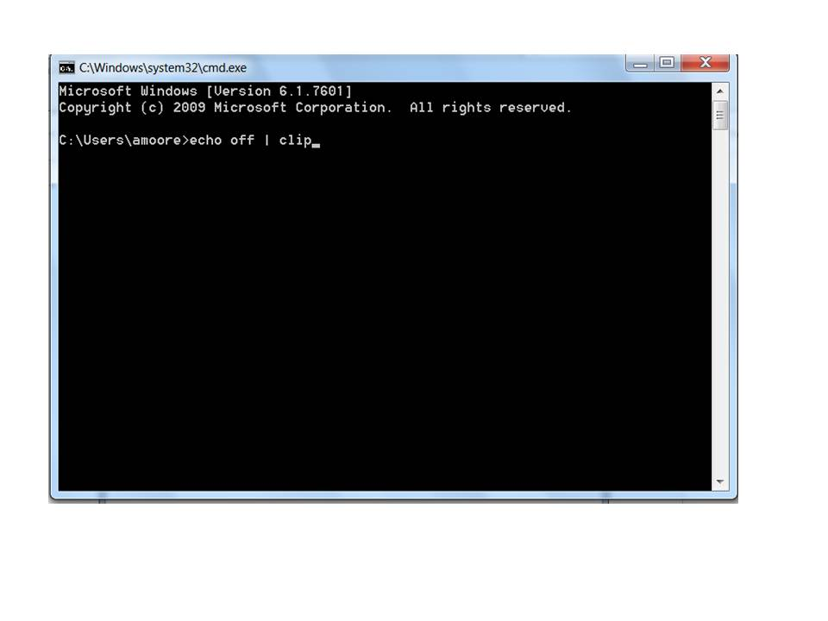

**Please read the User’s Guide and enjoy!**

# Introduction

## Purpose of the TIRP Tool

The Terminal Incident Response Plan (TIRP) tool was designed to support airport personnel in creating effective TIRPs for evacuation, sheltering-in-place (SIP) procedures, and repopulation for a variety of incidents that disrupt normal operations in airport passenger terminals. Users input information unique to their airport and the nature of the incident, and the tool will automatically generate a plan that adheres to specific airport terminal configurations, policies, and standard operating procedures (SOPs).

A TIRP includes separate actionable response plans for nine of the most disruptive types of incidents. These incidents are snowstorms, hurricanes, tornadoes, earthquakes, structural fires, electrical outages, bomb threats, security breaches, and active shooter incidents. For other types of incidents, users can adapt plans from the most closely related of the nine basic incidents (e.g., plans for an Internet outage can be adapted from plans for an electrical outage). As a Microsoft Word document, the TIRP can be further edited and customized to suit the specific needs of the airport. Designed to save users both time and trouble during disruptive events, the TIRP tool is easy to use and provides realistic, actionable response plans.

The tool *does not* generate a plan that duplicates an airport’s other essential plans such as the airport emergency plan (AEP) or the airport security program (ASP). Rather, the tool specifies where within existing plans a TIRP can provide additional guidance for managing passenger terminals during nonroutine incidents ranging from a single medical evacuation to a full-scale natural disaster. TIRPs generated using the tool can be used as AEP sections, as additions to incident-specific annexes in AEPs, or as stand-alone plans referenced in AEPs. They can also be incorporated into airport customer service manuals.

## Purpose of This User’s Guide

This guide directs airport operators, terminal managers, emergency managers, and planners step-by-step through the process of generating TIRPs using the TIRP tool. It explains how to run the tool, input data, obtain outputs, and customize outputs.

## Minimum System Requirement

The TIRP tool can run on a laptop or desktop computer using Microsoft Excel and Microsoft Word, including macros, from Microsoft Office version 2007 or later. At this time, it cannot be run on tablets, smartphones, or other handheld devices since Microsoft Office versions do not provide macro capabilities.

When the user downloads the TIRP tool’s Excel file from the Transportation Research Board website, the user must enable macros. Since the tool is a macro-enabled spreadsheet, the user’s Excel software will prompt the user to select “Enable this content” and “OK”to enable macros.

## What the TIRP Tool Can Do

The TIRP tool is an Excel spreadsheet with macros that receives inputs from the user, links them to appropriate plan text elements, calls for further detailed input as required, and produces a draft TIRP in a Word document that can easily be customized and shared with personnel responding to the incident.

## Inputs

Users enter specific data regarding airport characteristics, contacts, and existing plans (e.g., AEPs or airport security plans) by filling in an initial incident checklist along with a series of simple Excel data input forms. The forms use yes-or-no and fill-in-the-blank questions to select or deselect pertinent sections. Input forms allow the airport to insert maps, photos, or other graphics to display features such as evacuation areas, pathways, or the location of emergency equipment. These custom input methods create a TIRP tailored to the specific physical configuration and risk profile of the airport.

## Processing Within the Tool

The heart of the TIRP tool is an Excel spreadsheet that uses macros to select critical pathways, select pertinent text elements, and logically organize the elements of the plan into chapters.

## Outputs

The tool’s final macro converts the Excel output into a TIRP as a Word document that can be edited and further customized by the user. This document consists of separate chapters for SIP, evacuation, repopulation, and highest-impact incident types included via the initial incident checklist. Each chapter of the plan produced by the tool includes a checklist for all actions required by the plan. Additional chapters may be added to the plan by copying and editing the most related chapter and locally customizing it for other incident types (e.g., baggage system failure or air traffic control delays). Further guidance for selecting similar chapters is provided in the taxonomy of incident types in Table 6 of the main body of the report.

At the user’s discretion, the tool can also develop an appendix listing all related contact and coordination information. While this appendix may be useful when responding to incidents, it is not meant to replace contact lists required in the AEP, ASP, or other primary documents.

## What the TIRP Tool Cannot Do

* The TIRP tool does not include a logical process for making the initial decision to activate an evacuation or SIP plan. That decision is best made by a designated airport authority with direct understanding of the unique nature of both the airport and the incident. Users activate the TIRP when the decision to evacuate or shelter in place has been made or is obvious to airport or tenant employees in the terminal. The latter case often occurs during incidents with no warning.
* The tool is not designed for direct incorporation into an airport’s command, control, and communications system or for incorporation into a web-based coordination system. It is designed as a stand-alone program for generating TIRPs.
* The tool does not generate automatic updates. However, users can easily and quickly update TIRPs due to user-friendly input forms and robust internal processing capability.
* The tool does not generate training plans or drill and exercise scenarios. However, the TIRPs are highly suitable for use as training materials.
* Other important airport plans are referenced in the plan produced by the TIRP, but the TIRP does **not** automatically generate hyperlinks to those external plans and documents. Once an airport has its plan as a Word document, it can edit it to incorporate whatever links it desires to include. An example might be a link to the master contact list, AEP, customer service manual, or other relevant guidance.

**Directions for Using the Tool**

The following section provides detailed instruction with visual aids to help you develop and generate a personalized TIRP for your airport. Refer to the visuals and text for step-by-step instructions.

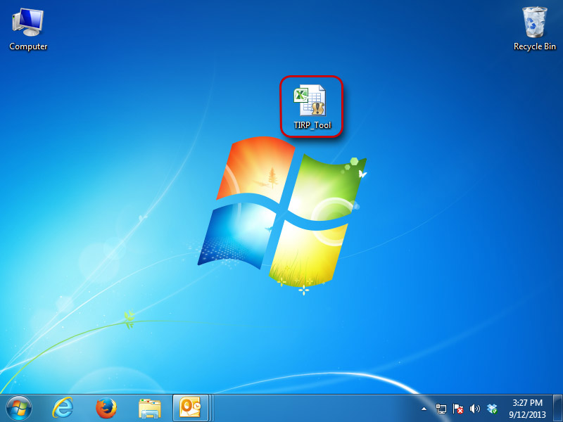

Figure 1. TIRP tool.

1. Download the tool from the Internet or from the CD-ROM into a folder location on your computer or to your desktop.
2. Double click on the Excel file “TIRP Tool” to launch the tool.



Figure 2. Initial macros screen.

1. You will be taken to the title sheet, and at this point you must enable macros for the program to function properly. Begin by clicking the “Enable Content” option button as displayed in Figure 2 for Microsoft Excel 2010 users. For Microsoft Excel 2007 users, follow step 4 to complete the enabling of macros/content.

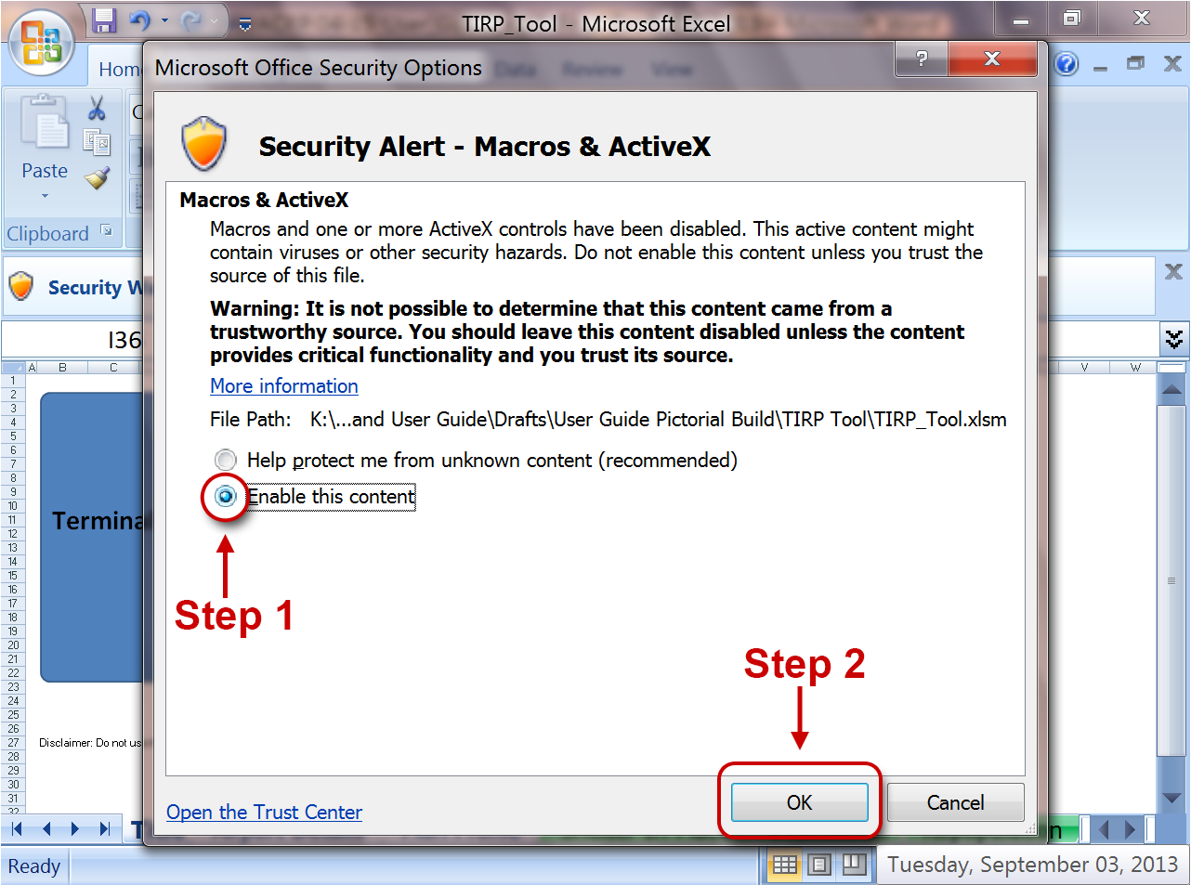

Figure 3. Enabling macros.

1. Users in Microsoft Excel 2007 will need to follow this additional step (Figure 3). Enable macros for Excel in the pop-up window by clicking“Enable this content” and then “OK.”The floating title page will pop up next (also known as the Control Form).

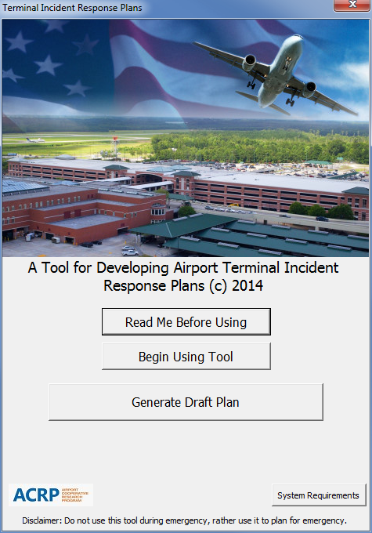

Figure 4. Title page buttons.

1. It is recommended that you click on the “Read Me Before Using” button prior to using the tool. It has several helpful hints to get you started (Figure 4).
2. You can also click on the “System Requirements” button to display minimum computer system requirements for the tool to run properly (Figure 4).
3. When you are ready to develop your terminal plan, click on the button that says “Begin Using Tool” (Figure 4)*.* You will then be taken to the Airport Details worksheet.

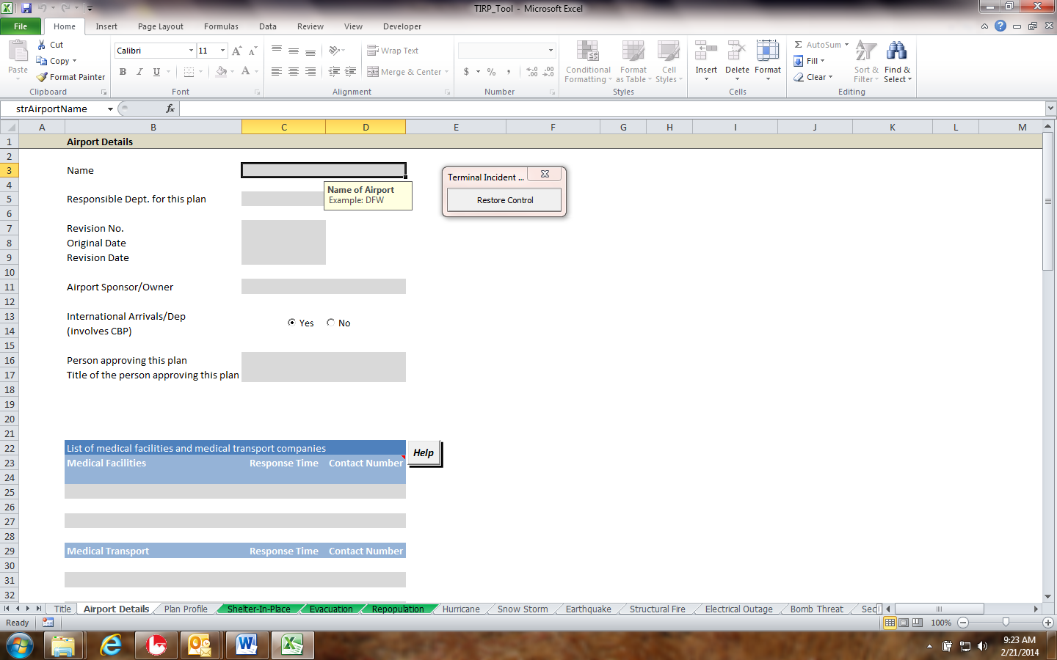

**Minimized**

Figure 5. Minimizing the title page.

1. Click the *X* in the upper right-hand corner of the floating title page to minimize it (Figure 5). You can then move the minimized title page to a location that is out of your way. You can also click either the *X* again or the “Restore Control” button at any time to open the title page back up.





Figure 6. Airport details page.

1. On the Airport Details worksheet fill in the gray blanks throughout the page with specific data and answer the yes-or-no question. Note: Figure 6 only shows a small portion of the airport details screen.



**Click Here**

Figure 7. Continue to plan profile button.

1. Once complete, move your mouse to the bottom of the airport details worksheet and click on the “Continue to Plan Profile”button (Figure 7). You will then be taken to the Plan Profile worksheet.



Figure 8. Choose airport type.

1. In the Plan Profile worksheet, choose your airport type, as shown in Figure 8.

**Will appear as a separate chapter in the TIRP document**



Figure 9. Airport terminal hazard risk analysis.

1. Scroll down and select the likelihood of the nine risk incident scenarios occurring at your airport (Figure 9). Any incident for which you click *very likely*, *likely*,or *somewhat likely* will appear as a separate worksheet in the TIRP and as a separate chapter in the TIRP output document. If you wish to include an incident with a lower risk at your airport, you must select at least *somewhat likely* to generate the chapter in the final document.

`

**Step Two**

**Step One**

Figure 10. Document list detail.

1. Below the Risk of Incidents section is a list of documents relevant to the TIRP (Figure 10). Populate the blanks in the table with all relevant documents. Note: You can enter as many lines as you need. Any lines or cells left blank will not appear in the final plan. These documents will be carried over to each subsequent form and will be displayed in a light-green non-editable table. You will be able to edit the section number and page number pertaining to the most appropriate section of each document as it applies to each unique hazard worksheet.
2. Once complete, click on “Continue to Shelter-In-Place.”



**Fill In**

**Auto Populated**

Figure 11. SIP page.

1. Fill in the blanks in each table of the Shelter-In-Place worksheet (Figure 11). Note: The light-green tables are auto-populated based on the list of relevant documents you created in the Plan Profile worksheet. The section numbers and page numbers of the auto-populated documents can be listed as indicated in Figure 11 to expedite identification of pertinent information.
2. Once complete, scroll down to the bottom of the worksheet and click on “Continue to Evacuation*.*”
3. Fill in the blanks in each table. Be sure to answer the two yes-or-no questions on the form.
4. Click on “Continue to Repopulation.”
5. Fill in the blanks in each table.
6. Click on “Continue to Incident Responses.” Depending on the risks you identified in the Plan Profile worksheet, you will be taken to a new worksheet for each respective incident.
7. Continue filling in each incident response type worksheet, being sure to populate the blanks (e.g., hurricane, snowstorm, and tornado).
8. Answer each yes-or-no question where relevant.
9. In each section, click the “Help” button at any time for information/assistance with that section as needed.

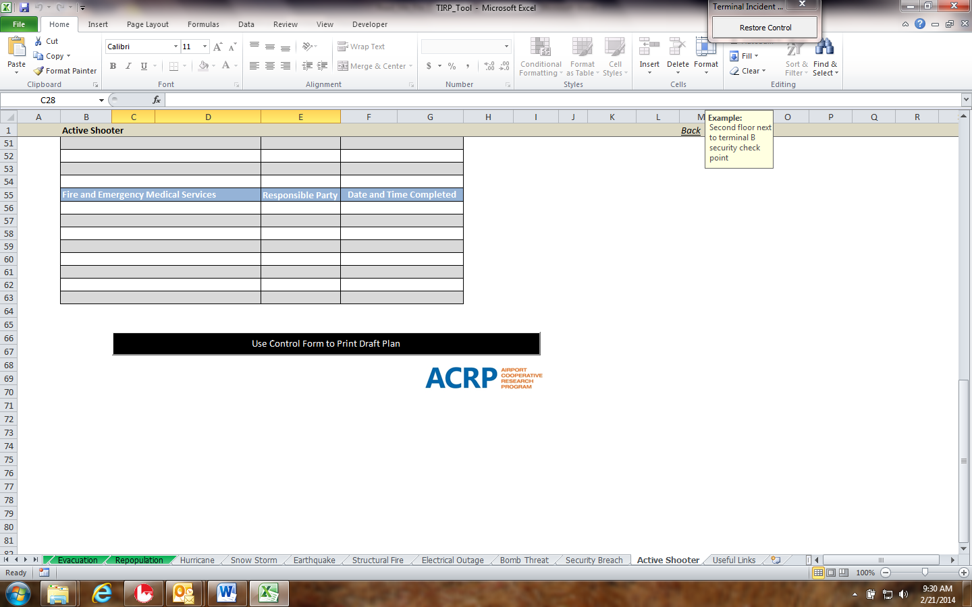

Figure 12. Generating your TIRP.

1. When you have completed the final incident response worksheet, click the “Use Control Form to Print Draft Plan”button at the end of the worksheet (Figure 12)*.*

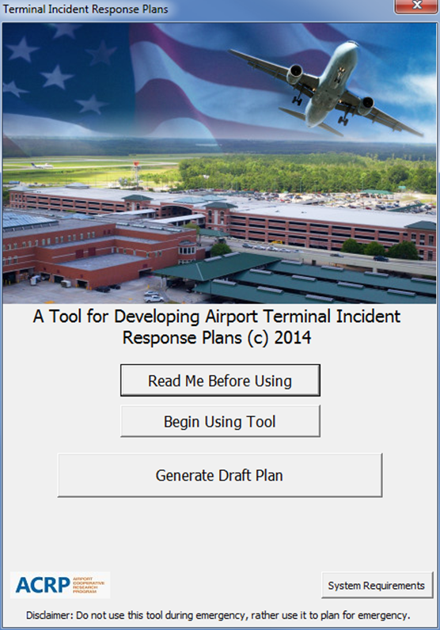

Figure 13. Generate draft plan button.

1. The title page will appear, and you can then select the “Generate Draft Plan”button. Note: If any Word documents are open, you will be prompted to save and close them. Microsoft Word must be closed prior to plan generation.

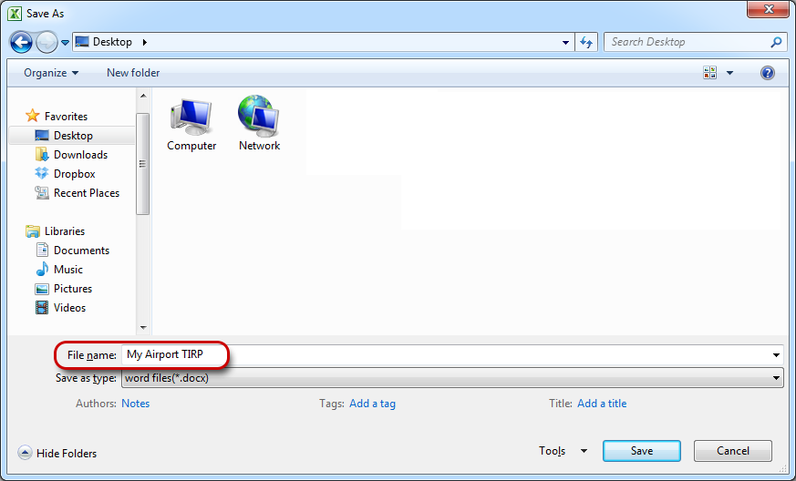

Figure 14. Saving your TIRP.

1. You will be prompted to name and save your plan. Save the plan document where you choose (desktop for instance) and name as appropriate for your airport. Note: Our example is “My Airport TIRP.” **WARNING: It is critical that each version of the plan that you save is saved with a unique name. If you attempt to name the plan as an exact or overwritten name of a previously generated plan, the tool will prompt you to create a new document.**
2. It will take some time for the tool to generate the plan. After several minutes, you will receive a message that the plan template was created successfully.
3. Once the plan is generated, it is recommended that you save the Excel file you used to create the plan with a **unique** name so you can implement version control for future updates.
4. Once the plan template is created, you can open the plan document and modify it according to your specific situation (e.g., add pictures, terminal-specific information, annual updates, custodial changes, or a separate page for hyperlinks.).
5. The tool is a means to an end, the end being a TIRP in Microsoft Word that you can further edit, add graphics to, and customize to your airport using Word functions. **Remember though, changes you make to the stand-alone word document do *not* get applied to the actual Excel-based tool itself!**

# Frequently Asked Questions

Q: What size airport is best suited to use the tool?

A: The tool has been designed to serve any size or type of airport. In beta testing, it worked well for two large hubs, two medium hubs, a small hub, a non-hub primary, and a reliever airport. In general, more customization via editing the Microsoft Word version of the terminal incident response plan produced by the tool will be needed by larger airports.

Q: Does the tool produce a complete and fully functional terminal incident response plan?

A: Yes and no. The tool will generate a NIMS-compliant complete plan for your airport; however, the plan produced should undergo a thorough airport review, training, and tabletop exercises prior to being considered fully functional.

Q: In what format is the basic terminal incident response plan produced by the tool?

A: It is a multi-chapter document in Microsoft Word (2010 or 2007).

Q: How long will it take to create a terminal incident response plan from the tool?

A: Depending on the complexity of the airport and how knowledgeable the staff member(s) preparing the plan are, it should take 30 minutes to 2 hours to use the tool and create the basic plan.

Q: How long will it take to customize the basic plan to create the final, fully developed terminal incident response plan?

A: For smaller airports, the basic plan produced by the tool can serve as is as the final terminal response plan. For larger airports, the customization process—editing the Word document version of the basic plan—should take 1 to 3 hours, depending on the extent of the changes and complexity of the site-specific information that the airport wishes to add.

Q: How long is the process to build a terminal incident response plan?

A: The best estimate for the development of a basic plan using the tool is 0.5 to 2.0 person-hours. The best estimate for the conversion (customization) of the basic plan to a fully developed, final terminal incident response plan is 0 to 3.0 person-hours. Altogether, the process from start to finished final plan is estimated to take 0.5 to 5.0 person-hours.

Q: Is there a need for specialized information technology (IT) folks to use the tool?

A: Probably not, depending on the ability of the airport emergency manager, terminal manager, operations supervisor, or planner to use Microsoft Excel and Microsoft Word.

Q: Can the tool be used by itself when an airport has an emergency for which it does not have a plan or has an outdated plan?

A: The tool was ***not*** designed or intended to be used as a plan or as a substitute for a plan. However, in an emergency when an airport does not have an existing plan, the tool can quickly produce a plan including basic SOPs and checklists. Note, however, that plans should be developed, trained, and exercised before being used in an actual emergency.

Q: Would the tool and resulting terminal incident response plan be legally binding on an airport to the exclusion of other existing emergency preparedness documents or plans?

A: No. The tool would provide structure and guidelines that may stand alone, supplement, or be used in concert with existing plans.

Q: Does the plan produced by the tool contain any sensitive security information (SSI)?

A: No, not unless the user inserts SSI text in one of the textboxes. If a user wants to be sure, the user should get the federal security director (FSD) and airport security coordinator (ASC) to review the plan. It is good practice to involve both the FSD and ASC as stakeholders in the development of terminal incident response plans.

Q: Isn’t repopulation just a matter of reversing the evacuation or shelter in place?

A: No, the sequence of actions and the responsibilities are different. For example, the terminal will have to have a structural, electrical, and mechanical evaluation before repopulation can begin. Furthermore, TSA and airport security will have to inspect and sanitize the secure portions of the terminal before any other employees or passengers can enter.

Q: Do only airport employees have roles and responsibilities in a terminal incident response plan?

A: Not usually. Using the tool’s inputs and the capabilities to edit the resulting Word document, the user can specify the roles and create action lists and checklists for any agency, airline, tenant, or mutual aid partner involved in terminal incident response. For this reason, these stakeholders should be involved in customizing and reviewing the plan.

Q: How can the plan be customized to deal with site-specific details?

A: There are three ways to customize the terminal incident plans produced by the tool:

1. By the data entered in the data blanks on data-entry pages of the tool,
2. By entering blocks of custom text in the textboxes while using the tool, and
3. By editing the resulting Word document.

Q: Should the resulting terminal incident plan be incorporated directly into AEP?

A: This is a choice that can usually be made by the airport. If the plan is incorporated directly into the AEP, any changes to the plan must be approved by the FAA compliance inspector. If the terminal incident response plan is not incorporated directly into the AEP, each pertinent part of it should be referenced within the plan. If in doubt, an airport should consult its FAA compliance inspector. Some airports have found it more practical or effective to have a separate terminal manual or a customer services manual.

Q: If the terminal incident response plan produced by the tool is incorporated into the AEP, will be it fully compliant with FAA Advisory Circular 150/5200-31C?

A: The plan developed by this tool is not required by Advisory Circular 150/5200-31C. The tool was designed on the assumption that the NIMS and ICS would be used in any response to any incident involving the terminal. The tool generates basic checklists and SOPs, but an airport may wish to edit the Word document to expand on them to fit site specifics. When in doubt about compliance with Advisory Circular 150/5200-31C, an airport should consult with its FAA compliance inspector.

Q: What stakeholders should be involved in using the tool, customizing the Word document, and reviewing the resulting terminal incident response plan?

A: Whether the terminal incident response plan is incorporated into the AEP or made a stand-alone plan, the same type of stakeholders suggested by FAA Advisory Circular 150/5200-31C should be involved. This includes units within the airport (senior management, terminal managers, emergency managers, operations managers, planners, ARFF, law enforcement, maintenance, and engineering). It also includes airlines, concessionaires, tenants, federal agencies, state agencies, and mutual aid partners.

Q: Can the tool be used as a training aid?

A: Yes. The whole package can be given to any stakeholder for training on terminal incident responses.

Q: What is the relationship between a terminal incident response plan and an airport’s drill and exercise program?

A: It is recommended that elements of the terminal incident response plan frequently be incorporated into tabletop exercises and even in full-scale functional exercises.

Q: Will the tool run on a Mac computer?

A: No.

Q: Can the tool be used by iPads, smartphones, or tablets?

A: It can be used on tablets and smartphones that have Microsoft Office applications. It cannot be used on iPads or iPhones.

Q: Is there an app available?

A: No, there is not an ACRP Terminal Incident Response Plan application available.

Q: Why aren’t there Mac, iPad, iPhone, and apps available?

A: The scope of the project only called for a tool to run on a PC, and the work plan and scope approved by the panel only called for a tool developed on Microsoft Excel.

Q: Will the tool run on Office 2007 and Office 2010?

A: Yes. The user’s manual and instructions imbedded in the tool allow the user to cope with differences between Excel 2007 and Excel 2010.

Q: Is the tool’s Excel code open source?

A: No. It is locked.

Q: How was the tool tested prior to release?

A: The tool was tested by the research team. Then it was tested by the ACRP project panel. Finally, it was beta tested at seven airports ranging from relievers to large hubs in size. A final test by the panel was completed before the tool was approved for release. After each test, adjustments were made to make the tool more user friendly.

Q: Where did the information and models come from that the research team used to develop the tool?

A: Thirty-six airports provided more than 100 documents, such as airport emergency plans, checklists, and SOPs, and these documents were analyzed using process mapping to determine the most common patterns of effective response. This information was combined with an exhaustive literature review of terminal incidents in the past 10 years.

Q: Is any special training required prior to using the tool?

A: No. The tool is very intuitive, and instructions are imbedded. Any moderately experienced airport emergency manager, operations supervisor, planner, or manager will be able to handle the inputs to the tool and customize the resulting Word document.

Q: Does the tool assume any particular organizational structure at an airport?

A: No. However, it does assume that the NIMS and ICS will be used as the basic organizational system for managing any response.

# Lessons Learned

1. Terminal incident response plans are better referenced by AEPs rather than incorporated directly into AEPs. Terminal incident response plans can be stand-alone documents or be incorporated into terminal management manuals or customer service manuals. Stand-alone documents will eliminate the need for FAA approval of all changes and edits, as is required for AEP changes.
2. Good terminal incident response plans are important for customer service.
3. Good terminal incident response plans are essential to optimize the business continuity of airports.
4. Terminal incident response plans must allow frequent changes and updates. This is driven by terminal renovations and expansions, new tenants, new concessionaires, changed procedures, and changed federal regulations and guidelines for airport operations and security.
5. The best plans result when a broad range of stakeholders are involved in plan creation, review, and implementation.
6. Mutual aid partners should be involved in the development of terminal incident response plans and in training, drills, and exercises of the plans.
7. Tabletop exercises are an effective way to test terminal incident response plans and their elements. When the terminal incident response plan is significantly changed, the new plan should be trained and tested with a tabletop exercise or a partial full-scale functional exercise.
8. Detailed checklists, even down to the responsibilities and actions of individuals, are important, maybe essential.
9. The NIMS and ICS are the best ways to organize and manage responses to incidents in terminals. Plans, training, drills, and exercises should incorporate the NIMS and ICS.
10. The terminal incident response plan should be reviewed after any activation, drill, or exercise to incorporate improvements suggested by after-action reviews.
11. The terminal incident response plans should be trained annually for all persons having responsibilities under the plan, with extra training when new employees are added.
12. Early notification and continued effective communications are essential to managing terminal incidents. Airport-specific notification and communication procedures should be identified within the terminal incident response plan.

# User’s Guide Bibliography

*Excel 2010: Advanced Student Manual.* (2011). Rochester, NY: Axzo Press.

Garabedian, R. (2011). *Microsoft Word 2010: A User’s Manual for Professors in the Humanities.* Amherst, MA: University of Massachusetts. Retrieved from http://people.umass.edu/rgarabed/microsoftword2010manual.pdf .

Loker, M. (2010). *Excel 2007:* *Creating Electronic Spreadsheets*. Oshkosh, WI: University of Wisconsin Oshkosh. Retrieved from http://www.uwosh.edu/training/training-manuals/microsoft-office/excel-2007-manuals/Excel2007CreatinganElectronicSpreadsheetManual.pdf/view.

New York City Department of Education (NYC). (2011). *Microsoft Office 2007 Word User Guide*. New York, NY: New York City. Retrieved from http://www.opt-osfns.org/dsf/reference/training_resources/msword/word/ug/word_ug.pdf .